# Instructions to run the test:

1. Download the project from Github and import the project in your workspace.
2. Make sure chrome is installed on your machine
3. To run the Project go to Run > Run configurations and create a maven build
   1. Creating Maven Build: Select “Maven Build” and click on New Configuration
   2. Give the configuration a name
   3. For Base directory, select the project
   4. In Goals give “Clean install”

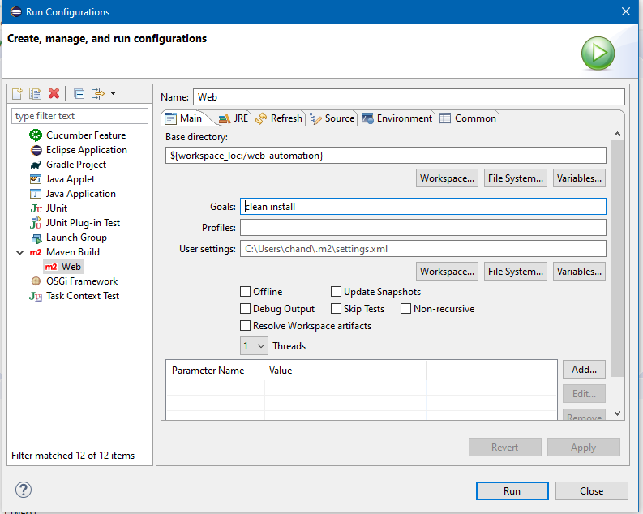

* 1. Click on “Apply” to save the changes and Click “Run” to execute the test

NOTE:

1. The cucumber.properties file within the *resources* folder (src/test/resources) will have the tag name of the scenario that needs to be executed. This file needs to be updated with the appropriate tag names.
2. The config.properties file within the *resources* folder (src/test/resources) will have the browser and driver info
3. The chromedriver is located within the *drivers* folder under the resources folder (src/test/resources)
4. The test that is executed can be found within the *features* folder under the resources folder (src/test/resources)

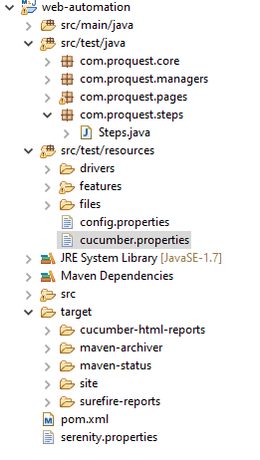

1. Test Results: The screenshot and the text file with the titles of all the google results can be found in the below location:

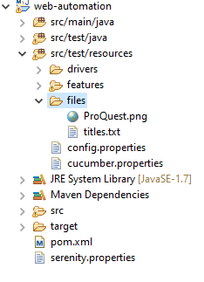

1. Test Results: The cucumber report can be found in the below location:

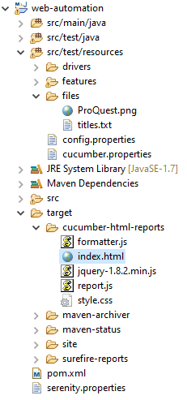

1. Test Results: The Serenity report can be found within the serenity folder. Look for a html file below “browsercongig.xml”:

